**St.Charles Boys Basketball**

- *300 Hour Club* -

Saints



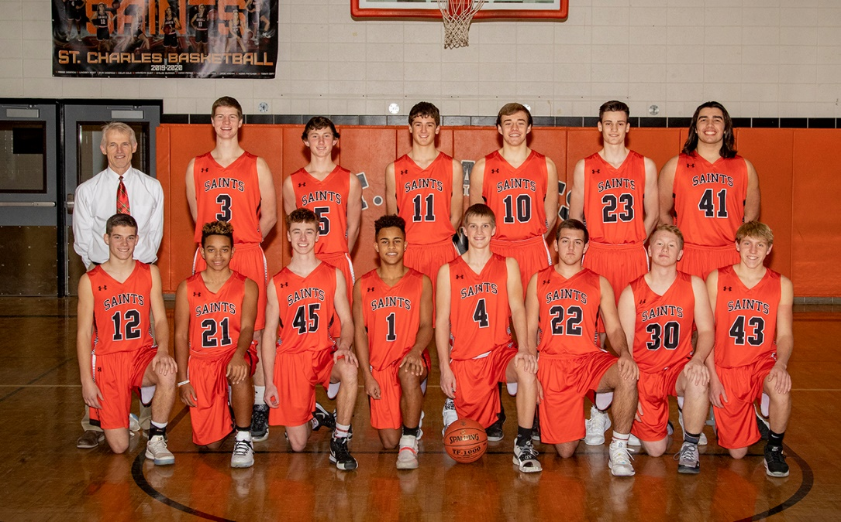

i

**St.Charles Boys Basketball**

**"300 Hour Club"**



# "No Deposit, No Return"

*Here's* a *reminder that no one has yet found* a *way to get something for nothing. All worthwhile goals come at* a *price, and the coins with which we pay are concentration, persistence and desire.*

It is often said that teams are made during the "in" season while players are made in the "off' season. It is with this premise that we have the St.Charles Basketball 300 Hour Club. The goal of the 300 Hour Club is for players to document over 300 hour of basketball related activities during the off-season. Players will set individual offseason goals, will be given a calendar, and will monitor their

basketball related activities on the calendar. The 300 club hours will start on March 15th. Players will turn this into Coach Knothe 1 after October 31st. All players who have earned over 300 Hours will receive a t-shirt and be recognized before a varsity basketball game. Players who reach the 400 Hour and 500 Hour Club will receive a t-shirt along with other awards.

**Players can earn hours in the following ways:**

* 50 hours for playing in a fall or spring sport
* 10 hours each for making the A or B honor roll in the spring and fall
* 1 hour for every hour spent in the weight room or training sessions.
* 1 hour for every hour of basketball you practice or play (includes: camps, summer games like Cotter, i.e.-3 games = 3 hours, shooting in driveway, playing 1 on 1, shooting at the shed or anywhere, etc.)
* Up to 20 hours of community service work will count toward the 300 hour club.
* Bonus Hours:

- 1 Bonus hour for every set of 100 Free Throws that you shoot.

- 1 Bonus hour if you complete an entire shooting off the hop workout plan you create.

**St.Charles Basketball Off-Season Goal Setting**

# "No Deposit, No Return,,

*Here's* a *reminder that no one has yet found* a *way to get something for nothing. All worthwhile goals come at*

a *price, and the coins with which we pay are concentration, persistence and desire.*

Name:

Grade next year: _

Today Date: _ What are my off-season g oals?

What is my detailed plan to reach these goals?

***Reflection in* October:** Do you believe you reached your off-season goals? Why or why not?

















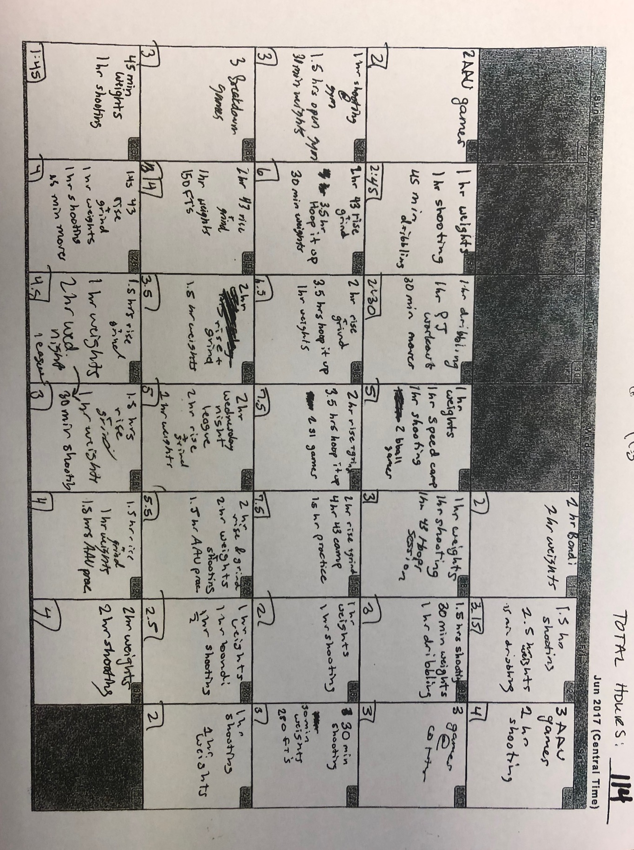

Sample monthly chart. You can include all basketball related activities from weight training to Cotter games, from shooting on the gun to playing in your driveway. Some things to remember:

*Our best shooters shoot off the hop. So hop into all shots.

*Pick a routine that forces you to work on ball handling(2 ball dribble drills are the best), free throw shooting, and moves to the rim as well as shooting drills. In todays game, if you cannot shoot, cannot get to the rim off the dribble, you probably will have trouble playing. There are a million workout sessions available to follow online – pick a great NBA player, research their workout routine and use it for you. Think Ja Morant, Trae Young, Lonzo Ball, Kemba Walker, Damian Lillard, Steph Curry – all top long range shooters. Follow a workout routine of theirs for instance.

*Good luck!